
Cottesloe Primary School Athletics Handbook

Dates:
Monday 16th August – Distance Runs, Throws, Long Jump & Triple Jump
Friday 20th August – Junior Tabloids & Senior Athletics Carnival
Schedule:
Junior Primary Tabloid Events:  PP & Year 1  Year 2 | (See attached run sheets)  9.00 – 10.00am  10.00 – 11.00am
Recess | 11.00 – 11.25am
Whole School Carnival | 11.25am – 3.00pm  *Lunch break at approximately 1.00 – 1.30pm  **PP-2 return to class after lunch
Presentations | 3.00 – 3.10pm (dependent on proceeding of events)

Officials:

Starter: Darren Taylor
Marshal: Sue Dwyer
Start Marshal: Parent
End Marshal: Parent
Announcer: Parent
Recorders: Parents

Judges:
1st: Parent
2nd: Parent
3rd: Beth Whitehead
4th: Katie Almeida
Chief Judge: G Dart

Bay Teachers:
Keane: Linda Visser
Forrest: Aleisha Niebieszczanski
Napoleon: Shelby Wilmot
Stirling: Courtney Bridge
Float: Brittany Hughes
Shields and Ribbons:
An overall shield is presented to the winning faction. Ribbons are awarded for individual events and relays (not including Flag Relays). Team games are not awarded with ribbons.

Parking:
Parents are requested to drop off/pick up only from the school side of Keane Street. The north side of Keane Street is designated NO STOPPING during school opening and closing times. Also, please adhere to all parking restrictions in Johnston Street which is designated NO STOPPING during school opening and closing times. “NO STOPPING” means that drivers can simply stop to drop off students or collect them if they are waiting there. Rangers have discretion to allow drivers to get out of their cars, but they should not move away from vehicle by any more than 5 metres. Parking the car and walking into the school will invoke a ticket.

Cottesloe PS has a drive through on the school side of Keane Street. These are yellow marking on the road designating the area for this drive through. The drive through can be used between 8.15 and 8.50am as listed on the signposts. NO PARKING (by law) is permitted in the drive through area during this time.

The staff car park is restricted to staff. Limited space does not permit the staff car park to be used for pickups or drop offs. It is also requested not to park in the school driveway on Keane Street to ensure access for emergency and delivery vehicles.

Spectators:
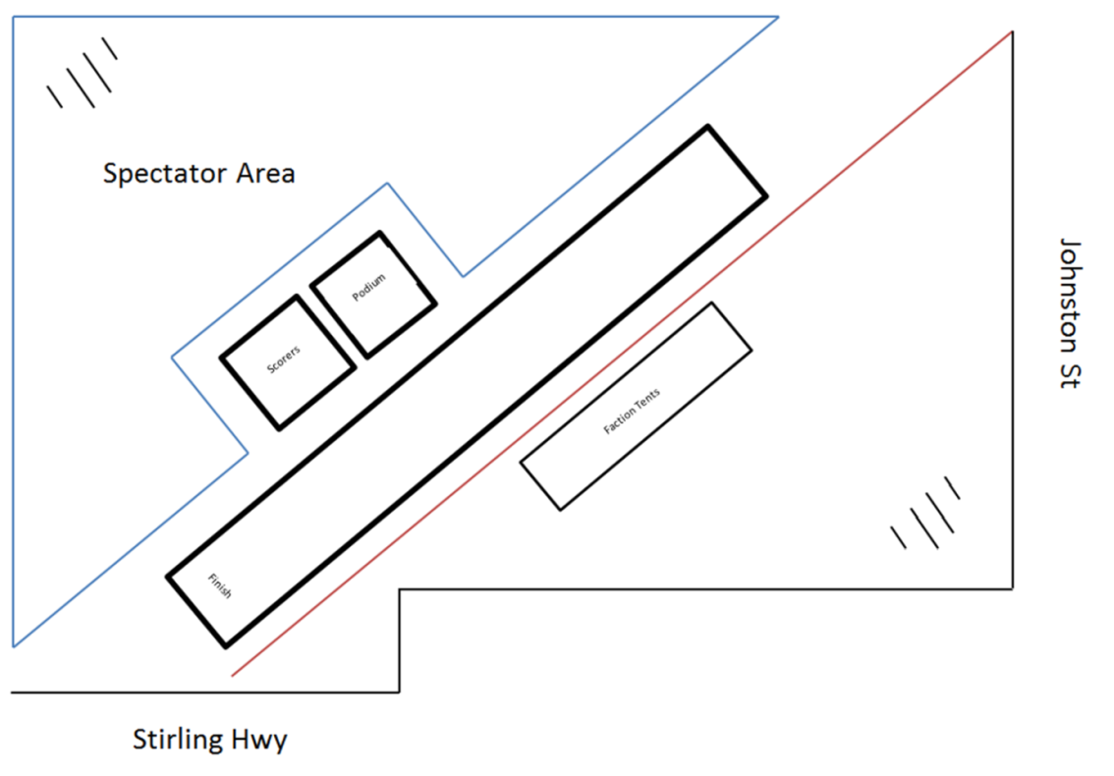
Parents and spectators are required to observe from behind bunting on the north-eastern end of the oval to ensure efficient operation of the carnival. Only judges are to be at the finish line in order for them to make decisions with uninterrupted views.
Conditions
- Students shall participate in year level groups.
- The faction’s two fastest runners in each age group shall be entered in “A” division. The next two fastest runners shall be entered in “B” division, and so on.
- Place ribbons for 1st, 2nd, 3rd and 4th will be awarded to successful competitors immediately after each individual and relay event (not including Flag Relays). No ribbons will be awarded for team games.
- Team games – If there are not enough girls or boys for a team in a particular year group, fill positions with students from a lower age group.
- Shoes are to be worn for every event. No spikes to be worn by any competitor.
- All equipment will be provided by the school to ensure fairness for all competitors.
- Point allocation:
1st 2nd 3rd 4th
Individual Events 5 3 2 1
Team & Relay Events 10 6 4 2
- Starting Instructions for sprints
  - Take your marks (move both feet to line and stand straight)
  - Set (one foot back and adopt body position for running)
  - Whistle/Horn
  - A false start is indicated by a second whistle blast. Minor breaks will not be recalled.
- Finishes: In all team games the last competitor or leader will run across the team finishing line and must wait to receive their place card. In Leaderball, Passball and Tunnelball, the leader should ensure the judges can see they are holding the ball as they cross the line. Judges will give a place card to the team leaders at the finish line. The leader (and only the leader) must then take the place card to the recorders desk to have their result recorded.
- Each competitor should compete in faction colours.
- All Leaderball teams consist of 8 members.
All Passball teams consist of 8 members.
All Flag Relay teams consist of 6 members.
All Shuttle Relay teams consist of 4 members.
Students competing in the Shuttle Relay may not participate in the Flag Relay, except in a situation where there are not enough remaining competitors.
- Long Jump is to be measured from the edge of the launching mat (the edge that is closest to the sand pit) to the closest imprint in the sand left from the jumper’s body. Jumps will not be considered if any part of the jumper’s foot lands over the measuring edge of the launching mat, but this will count as a turn. In the Long Jump event, students are given three attempts. The winner will be the person who achieves the longest jump.
- Triple Jump is to be measured from the end of the launching mat (the edge that is closest to the sand pit) to the closest imprint in the sand left from the jumper’s body. The technique must be a “hop, step and jump”. The hop shall be made so that an athlete lands first on the same foot as that from which he/she has taken off; in the step he/she shall land on the other foot, from which, subsequently, the jump is performed. In the Triple Jump event, students are given three attempts. Jumps will not be considered if any part of the jumper’s foot lands over the measuring edge of the launching mat, but this will count as a turn. The winner will be the person who achieves the longest jump.
- Throwing events use a vortex. An overarm throw technique must be used (a straight arm throw will not be accepted). Measurement occurs at the location of which the vortex lands. A foul will be called if the thrower oversteps the line or throws the ball outside the throwing area. Throwers are given three attempts. Foul throws count as an attempt. The winner will be the person who achieves the longest throw.
- Long distance runs will utilise the following course:
  - 200m – start next to the northernmost AFL goals, students run around the southernmost AFL goals, run towards the start of the race track and finish at the western end of the race track (next to Stirling Hwy)
  - 400m – start next to the northernmost AFL goals, students run around the southernmost AFL goals, northernmost AFL goals, southernmost AFL goals again, run towards the start of the race track and finish at the western end of the race track (next to Stirling Hwy)
  - 800m – start next to the northernmost AFL goals, students run around the AFL goals three times (running in an anticlockwise direction around the southernmost goals first) and finish at the western end of the race track (next to Stirling Hwy)
- Champion Boy/Girl and Runner Up Boy/Girl are awarded to students who have achieved the highest points from individual events in their year level. Only students who competed in Div A for their sprint will have their points contribute towards the Champion Boy/Girl award.
- In the event that the judges can’t agree on a decision, the chief judge’s decision will be final.

Passball Rules
BALL Netball - Stitched, panelled - Size 5
STARTING COMMANDS 1. Take your marks All up straight
2. Set Leader picks up ball ready to start
3. Whistle Go
RULES
- Game begins with the ball in the hands of the leader.
- Team of 8 with 5 in each of two lines 3 metres apart (Years 4 and 5) and 4 metres apart (Years 6 and 7), each child 2 metres from his/her neighbour and opposite a space in the opposite line. The first child (the leader) has his/her right shoulder to the finishing line.
f
i leader    
n 10m 3-4m
i 1m offset    
s 2m apart
h
- The ball passes diagonally from player to player two times up and down the line and the leader then runs 10 metres with the ball to the finishing line. The front foot must be kept in contact with the spot before and after the ball is thrown. The back foot may follow through provided the ball has left the hands before the foot comes in contact with the ground. The ball must be caught with the forward foot on or behind the dot. This avoids students shortening distances for passes.
- If the ball is badly passed so that it does not reach the player for whom it is intended or goes beyond that player, the receiver only picks it up, returns to his/her place and then throws. Other team members must not attempt to block or fetch a ball intended for someone else.
- If a ball ricochets into another team, the person for whom the ball was intended must take care not to interfere with the other team's passing.
- A shoulder or chest pass may be used.
- The rule of "unfair advantage" shall take precedence in any dispute.
- Team members may elect to have their feet stay still (i.e. avoid stepping)
- At completion, leader runs to the finish line and holds the ball as they cross the finish line

Leaderball Rules
BALL Incrediball T-Ball All years
STARTING COMMANDS 1. Take your marks All up straight
2. Set Leader picks up ball and may step, ready to start
3. Whistle Go
- Team of 8 for Years 3 -6, each child 1 metre from neighbour. Leader with back to finishing line and 10 metres from it, faces team 4 metres from the first player. Leader throws the ball to the first player who catches it, places the ball on the spot, runs clockwise around the back of the team, then round the leader, back to spot, picks up the ball, throws the ball to the leader and sits. Leader throws the ball to the second player, who follows the same course as the first. The game continues until the last player has run and thrown the ball to the leader. Leader turns and runs with the ball to the finishing line. The leader must make contact with his/her foot with the spot before running to the finish line.
- The runner must not touch any other player.
- Throwing: Every time the ball is thrown the thrower must have at least one foot on the spot.
The leader should throw to the right hand of the team.
- Catching: If a player has to move from the spot to take the catch he/she must return and place the ball on the spot before running.
- The ball must be placed on to the spot after being caught (not dropped or thrown).
- If a catcher misses the ball or it ricochets from his/her hand, only he/she may retrieve it.
- Only the person for whom the ball was intended may touch the ball if it does not remain on the spot.
- The leader and the last runner must be standing erect with both feet on the spot when players run around them.
- The rule of "unfair advantage" shall take precedence in any dispute.

NOTE The leader should hold the ball above his/her head when crossing the finishing line.
f
i Leader Runner
n 10m  2m  1m      (Years PP-2)
i
s  3m  1m        (Years 3-6)
h

Flag Relay
EQUIPMENT:
1 "Head" tin approximately 28cm across top, 23cm high (plastic bucket or classroom bin size)
4 Small tins approximately 13cm across top, 15cm high (jam tin size)
4 Pieces of hose, 2.5cm diameter, 30cm - 35cm in length.

STARTING COMMANDS

1. Take your marks First runner at cone 1 (nearest "head" tin) standing up straight; others sitting behind cone 2 (nearest finish line).
2. Set
2. Whistle Go.

RULES
- Teams of 6 runners (they may not compete in the shuttle relay)
- "Head" tin 5m from runners' cone.
- Runner stands at cone nearest "head" tin. When running, next team member may move up to front cone. The only runners standing at any time are the actual runner and the one at cone 1.
- Flags/sticks start in "head" tin. First runner puts out flags/sticks individually and, after placing last stick out, runs back, tags second runner and sits behind the others.
- Runner 2 collects flags individually from small tins and places them in the large "head" tin. After placing fourth flag/stick in the tin, s/he tags runner 3 and sits behind the others.
- Third, fourth, fifth and sixth runners repeat in sequence.
- Sixth runner, on completion, runs past whole team to the finish line, 10m back from cone 1.
- Any flags/sticks that fall to the ground from "head" tin must be `touched' into "head" tin, then taken.
- Any errors (flags on ground or two flags in any one small tin) must be corrected by the runner on the field at that time - NO OTHER RUNNER.
- The rule of "unfair advantage" shall take precedence in any dispute.

f
i cone 2 cone 1 2m 2m 2m 2m
n ☺☺☺☺☺ ☺ 5m  □ □ □ □
i 5m 5m "Head"
s tin
h
The rule of “Unfair Advantage” takes precedence.
1) Disqualification is a last resort and should be avoided where possible.
2) Where a breach has resulted in an advantage the team will be relegated one place down.
3) The team may be relegated 2 or more places if that is more appropriate.
4) In exceptional circumstances the event can be re-run.
The above decisions are made by the chief judge in consultation with the carnival organiser.
Referees should point out any errors as teams are playing to avoid further problems.

Hurdles
EQUIPMENT:
Height and flights to be determined by CRSSG meetings. 2019 agreement: hurdles are approximately 43cm high and 1.2m wide.
Ensure hurdles are set up so they are approached in the direction they were designed Eg: legs facing the start line, designed to fall toward the finish line.
STARTING COMMANDS
Same as standard running events 400m and shorter: Take your mark, set, horn/whistle/clapper
RULES
· Hurdle races are run in lanes and as such athletes must stay in their lane
· Athletes may unintentionally knock hurdles and not be disqualified
· An athlete may be disqualified if they are deemed by the chief judge to have deliberately knocked down hurdles, whether by hand or foot.
ADDITIONAL INFORMATION:
· Ensure students only approach and run through hurdles in the correct direction
· Refrain from referring to “jumping over” hurdles, instead we “run through” hurdles.
FLIGHTS AND SETUP:
Lead-in: 12m
Lead-out: 13m
Distance between flights: 7m
Flights: 6

Junior Tabloid Stations (PP/Yr 1)
Each year group will have 30 mins for tabloid stations and 30 mins for team events. All tabloid stations will run for 6 minutes each and will include
- Basketball shots at hoop
- Bean Bag Relay
- Baton Relay
- Dribble hockey ball through cones
- Dribble soccer ball through cones
PP/Yr 1 | Shooting Hoops (1) | Bean Bag Relay (2) | Hockey Dribble (3) | Baton Relay (4) | Soccer Dribble  (5)
9.00 – 9.06 | Forrest |  | Napoleon | Stirling | Keane
9.06 – 9.12 | Keane | Forrest |  | Napoleon | Stirling
9.12 – 9.18 | Stirling | Keane | Forrest |  | Napoleon
9.18 – 9.24 | Napoleon | Stirling | Keane | Forrest
9.24 – 9.30 |  | Napoleon | Stirling | Keane | Forrest
There will be a faction captain at each station to explain the rules and other Year 6’s to assist with scoring.
Following the tabloid stations, all students will congregate to their faction tents. They will be organised for modified team events. These events include
- Passball
- Tunnelball
- Leaderball
- Tamaire (if time permits)
Each team event will run for approximately 8 minutes. It’s likely that we will be able to do one practise event and then one “final” event.

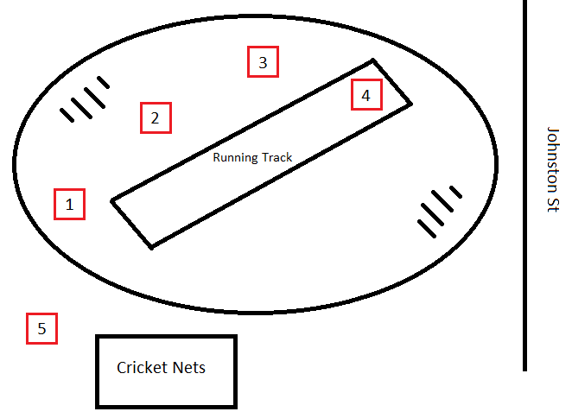

Junior Tabloid Stations (Year 2)
Each year group will have 30 mins for tabloid stations and 30 mins for team events. All tabloid stations will run for 6 minutes each and will include
- Basketball shots at hoop
- Bean Bag Relay
- Baton Relay
- Dribble hockey ball through cones
- Dribble soccer ball through cones
Yr 2 | Shooting Hoops (1) | Bean Bag Relay (2) | Hockey Dribble (3) | Baton Relay (4) | Soccer Dribble  (5)
10.00 – 10.06 | Forrest |  | Napoleon | Stirling | Keane
10.06 – 10.12 | Keane | Forrest |  | Napoleon | Stirling
10.12 – 10.18 | Stirling | Keane | Forrest |  | Napoleon
10.18 – 10.24 | Napoleon | Stirling | Keane | Forrest
10.24 – 10.30 |  | Napoleon | Stirling | Keane | Forrest
There will be a faction captain at each station to explain the rules and other Year 6’s to assist with scoring.
Following the tabloid stations, all students will congregate to their faction tents. They will be organised for modified team events. These events include
- Passball
- Tunnelball
- Leaderball
- Tamaire (if time permits)
Each team event will run for approximately 8 minutes. It’s likely that we will be able to do one practise event and then one “final” event.

31. Year 1 Boys 50m Div 1
32. Year 1 Boys 50m Div 2
33. Year 1 Boys 50m Div 3
34. Year 1 Girls 50m Div 1
35. Year 1 Girls 50m Div 2
36. PP Boys 50m Race 1
37. PP Boys 50m Race 2
38. PP Boys 50m Race 3
39. PP Girls 50m Race 1
40. PP Girls 50m Race 2
41. PP Girls 50m Race 3
42. PP Girls 50m Race 4
43. Kindy Race 1
44. Kindy Race 2
45. Kindy Race 3
46. Kindy Race 4
47. Year 3 Mixed Flag Race
48. Year 4 Mixed Flag Race
49. Year 5 Mixed Flag Race
50. Year 6 Mixed Flag Race
51. Year 2 Boys 50m Div 1
52. Year 2 Boys 50m Div 2
53. Year 2 Boys 50m Div 3
54. Year 2 Girls 50m Div 1
Cottesloe Primary School 2021 Athletics Carnival
9am—9.30 am*
1. Year 3 Boys 200m Race
2. Year 3 Girls 200m Race
3. Year 4 Boys 200m Race
4. Year 4 Girls 200m Race
5. Year 5 Boys 400m Race
6. Year 5 Girls 400m Race
7. Year 6 Boys 800m Race
8. Year 6 Girls 800m Race
9.30 – 11.00am*
9. Year 3 Boys Vortex Throw
10. Year 3 Girls Vortex Throw
11. Year 4 Boys Vortex Throw
12. Year 4 Girls Vortex Throw
13. Year 5 Boys Vortex Throw
14. Year 5 Girls Vortex Throw
15. Year 6 Boys Vortex Throw
16. Year 6 Girls Vortex Throw
Monday 16th August
55. Year 2 Girls 50m Div 2
56. Year 2 Girls 50m Div 3
57. Year 3 Boys 75m Div 1
58. Year 3 Boys 75m Div 2
59. Year 3 Boys 75m Div 3
60. Year 3 Boys 75m Div 4
61. Year 3 Girls 75m Div 1
62. Year 3 Girls 75m Div 2
63. Year 3 Girls 75m Div 3
64. Year 3 Girls 75m Div 4
65. Year 3 Mixed Tunnelball
66. Year 4 Mixed Tunnelball
67. Year 5 Mixed Tunnelball
68. Year 6 Mixed Tunnelball
69. Year 4 Boys 75m Div 1
70. Year 4 Boys 75m Div 2
71. Year 4 Girls 75m Div 1
72. Year 4 Girls 75m Div 2
73. Year 3 Boys Hurdles
74. Year 3 Girls Hurdles
75. Year 4 Boys Hurdles
76. Year 4 Girls Hurdles
77. Year 5 Boys Hurdles
78. Year 5 Girls Hurdles
79. Year 6 Boys Hurdles
80. Year 6 Girls Hurdles
81. Year 3 Mixed Passball
82. Year 4 Mixed Passball
83. Year 5 Mixed Passball
84. Year 6 Mixed Passball
85. Year 5 Boys 100m Div 1
86. Year 5 Boys 100m Div 2
87. Year 5 Boys 100m Div 3
88. Year 5 Boys 100m Div 4
89. Year 5 Girls 100m Div 1
90. Year 5 Girls 100m Div 2
91. Year 6 Boys 100m Div 1
92. Year 6 Boys 100m Div 2
93. Year 6 Boys 100m Div 3
94. Year 6 Girls 100m Div 1
95. Year 6 Girls 100m Div 2
96. Year 6 Girls 100m Div 3
97. Year 3 Mixed Leaderball
98. Year 4 Mixed Leaderball
99. Year 5 Mixed Leaderball
100. Year 6 Mixed Leaderball
101. Year 3 Boys 75m Relay
102. Year 3 Girls 75m Relay
103. Year 4 Boys 75m Relay
104. Year 4 Girls 75m Relay
105. Year 5 Boys 100m Relay
106. Year 5 Girls 100m Relay
107. Year 6 Boys 100m Relay
108. Year 6 Girls 100m Relay
109. Super Relay (if time)
110. Tamaire (if time)

PRESENTATIONS
(approx. 3pm)
Friday 20th August
17. Year 3 Boys Long Jump
18. Year 3 Girls Long Jump
19. Year 4 Boys Long Jump
20. Year 4 Girls Long Jump
21. Year 5 Boys Long Jump
22. Year 5 Girls Long Jump
23. Year 6 Boys Long Jump
24. Year 6 Girls Long Jump
25. Year 4 Boys Triple Jump
26. Year 4 Girls Triple Jump
27. Year 5 Boys Triple Jump
28. Year 5 Girls Triple Jump
29. Year 6 Boys Triple Jump
30. Year 6 Girls Triple Jump
Junior Tabloid
Carnival
Friday 20th August

PP/1—9-10am
Year 2—10-11am
*Times are all approximate

